INTERNSHIP REPORT

COURIER SERVICE APP
Student Name:Jiya Sajeevan
Register Number:PNAYSCS021
Programme:BSC COMPUTER SCIENCE
College:PRAJYOTI NIKETAN COLLEGE PUDUKAD
Internship Organization:ziuke infotech
Total Hours Completed:60 hours
Industry Supervisor:Sruthi Sunil

ACKNOWLEDGEMENT
I express my sincere gratitude to my industry supervisor(s) for their valuable guidance, encouragement, and continuous support throughout the internship period. Their professional advice helped me gain practical knowledge of real-world software development.
I would also like to thank the host organization for providing me with the opportunity to work on the Courier Service App project. This internship helped me understand industry practices and apply my academic knowledge.
I extend my heartfelt thanks to my internal supervisor and college faculty for their guidance and support. Finally, I thank my family and friends for their encouragement.

EXECUTIVE SUMMARY
This internship report presents a comprehensive overview of the internship undertaken on the development of a Courier Service App. The objective of the internship was to gain hands-on experience in designing and developing a real-time application used for managing courier bookings, tracking shipments, and delivery management.
The application includes modules such as user registration, parcel booking, pickup scheduling, real-time tracking, delivery status updates, payment processing, and notifications.
Various tools such as HTML, CSS, backend programming languages, MySQL database, UML diagrams, and documentation tools were used. The internship enhanced my technical and professional skills.

INTERNSHIP CERTIFICATE

TABLE OF CONTENTS
Chapter 1: Organization Profile
Chapter 2: Internship Overview
Chapter 3: Internship Experience
Chapter 4: Learning Reflection

CHAPTER 1: ORGANIZATION PROFILE
The internship was carried out at an organization specializing in software development and IT-enabled services. The organization focuses on building scalable, secure, and user-friendly applications for logistics and courier services.
The company follows standard Software Development Life Cycle (SDLC) practices and encourages teamwork and innovation.

CHAPTER 2: INTERNSHIP OVERVIEW
The internship was conducted for a duration of 60 hours.
Objectives included understanding courier workflows, application development, database management, and documentation.
Departments worked in included development, database management, testing, and documentation.
Tools used included HTML, CSS, backend languages, MySQL, UML tools, and MS Word.

CHAPTER 3: INTERNSHIP EXPERIENCE
Tasks performed included requirement analysis, application design, database creation, development, testing, and documentation.
The Courier Service App supports parcel booking, pickup scheduling, real-time tracking, delivery management, and online payments.
Challenges included tracking accuracy and data consistency, which were resolved through supervisor guidance.

CHAPTER 4: LEARNING REFLECTION
The internship bridged the gap between academic knowledge and practical experience. Real-world development required problem-solving, debugging, and teamwork.
The internal supervisor provided regular guidance, feedback, and support.

APPENDICES
Appendix A: Internship Photo with Timestamp
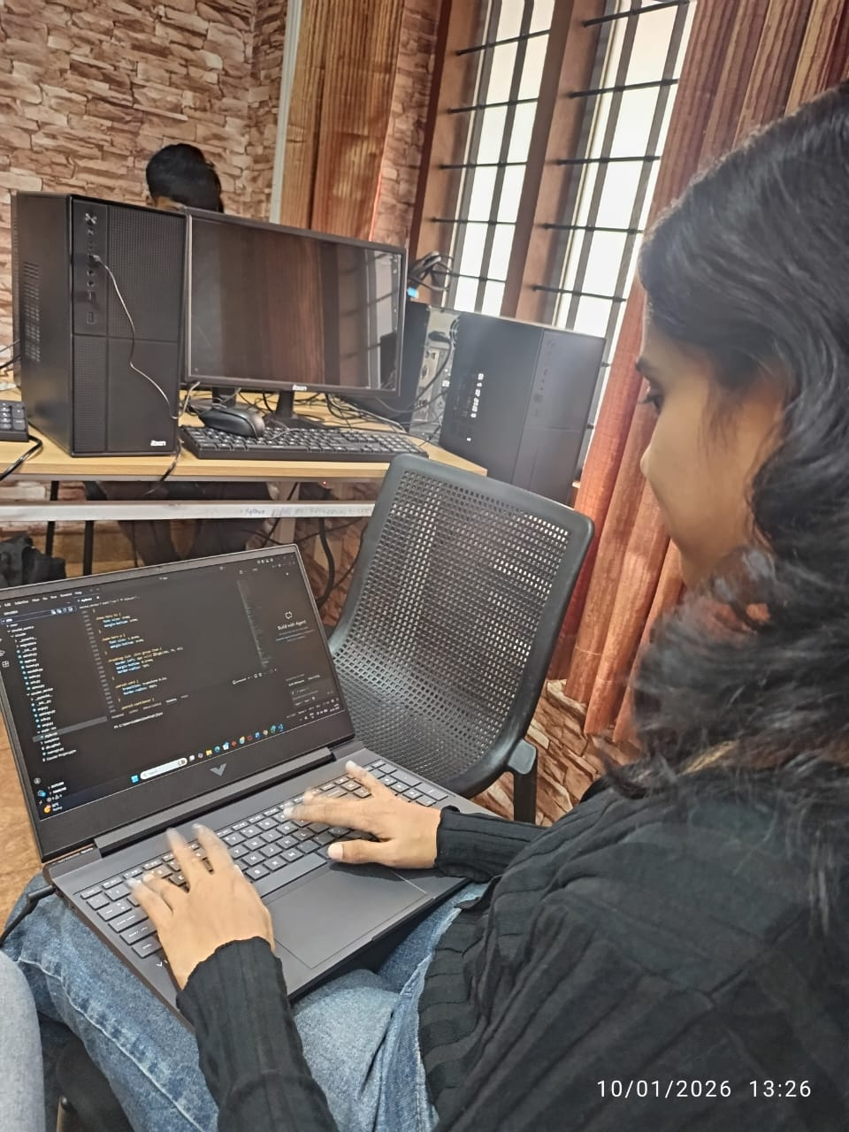
Appendix B: Workbook Summary including daily activities and learning outcomes.
click here

